Class 2 Theme for Autumn term:
Empathy/Keeping safe and healthy

Learning Outcomes:

To understand what empathy means and why it is important.

To learn rules for and practise simple ways of keeping safe and finding help in lots of situations.

To understand about healthy eating and keeping ourselves clean and why that is important especially with regard to hand washing.

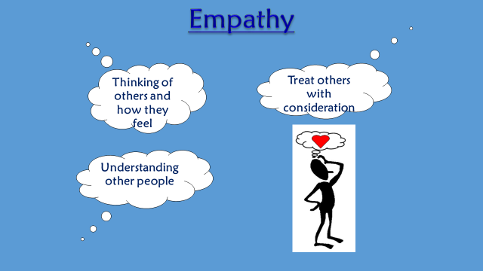
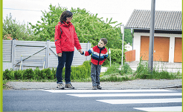
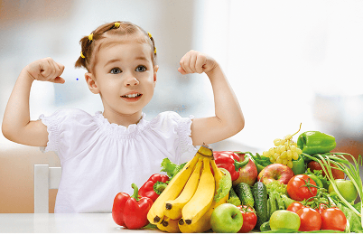

Topic specific vocabulary:-

Empathy feelings emotions

safe avoid risk choice
dangerous trust

healthy unhealthy allergies,
responsible germs immunisation vaccine

