Activity 4: Field Sketch
Draw a brief field sketch of their river, looking either up or down stream. Use a compass, to record the direction they are looking at whilst sketching and also which direction the river is flowing. Label your sketch using the word bank at the bottom of this sheet
Here is an example:
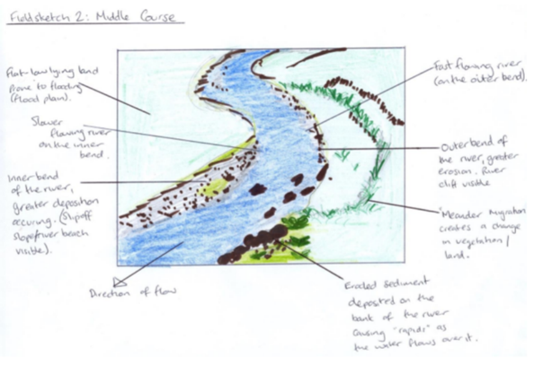

Word bank: river riverbank flow rocks upstream
downstream current tributary rapids clapper bridge
gorse beach sand

