Class 1 Autumn Term
Design Technology Challenge
Name:…………………………

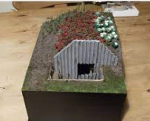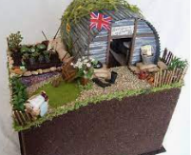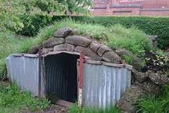

Build your model version
of an
Anderson Shelter

Learning objective: Children can work from their plans previously drawn to create a sturdy 3d model of an Anderson shelter.
Learning objective: Children can display and discuss their work while positivity observing the rest of their classmates models.
Time Scale:
29/9/22 Project launched – research and find out about Anderson Shelters
6/10/22 Initial designs created and list of materials compiled
13/10/22 Take home materials complied at school, with a clear brief of how you are going to create your model
YOU HAVE 5 weeks to create your model, they must be brought into school on Thursday 17th November to be marked.
Feedback on each other’s work.

We will hold an OPEN AFTERNOON on Thursday 24th November for parents to come in and see everyone’s models.

Success Criteria:

Great: I am able to create a sturdy Anderson Shelter model using my well thought out plan.

Fantastic: I am able to independently create a sturdy Anderson Shelter model using a descriptive plan.

Amazing: I am able to work on my own to use my highly detailed plan to create a well constructed and thought about model.

OBJECTIVES:

National Curriculum KS2 D&T –

Make-

-select from and use a wider range of tools and equipment to perform practical tasks [for example, cutting, shaping, joining and finishing], accurately

-select from and use a wider range of materials and components, including construction materials, textiles and ingredients, according to their functional properties and aesthetic qualities

-investigate and analyse a range of existing products

Evaluate-

their ideas and products against their own design criteria and consider the views of others to improve their work

understand how key events and individuals in design and technology have helped shape the world.’

WE WILL TEST YOUR SHELTERS:
- WILL THEY WITHSTAND WATER (100ml)
- CAN THEY PROTECT YOU FROM A BOMB BLAST (HOLD a 1kg WEIGHT)
- CAN A LEGO MAN GO INSIDE YOUR ANDERSON SHELTER

29/9/22
Researching Anderson Shelters

5 interesting facts about Anderson Shelters:
- ________________________________________________________________
- ________________________________________________________________
- ________________________________________________________________
4._________________________________________________________________
5___________________________________________________________________

What else did you find out?

What was the purpose of the Anderson Shelter?

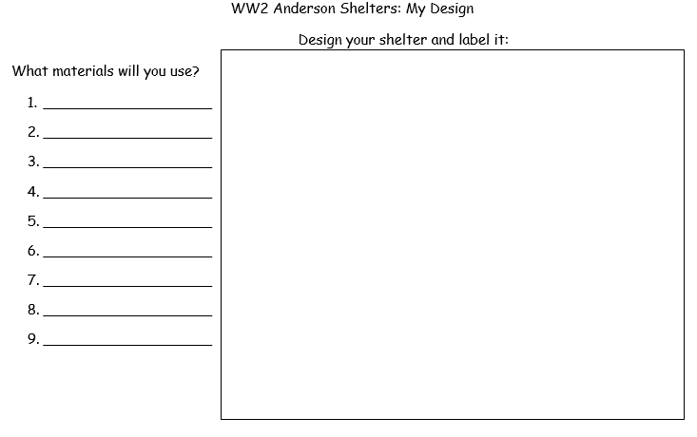
To be completed at home
Write how you made your Anderson Shelter or take photos of the skills you used. Can you list the skills?

Write a set of instructions on how you built your Anderson Shelters (use a range of time connectives such as, first, then, after that and imperative verbs, such as , cut, paint, stick).

17/11/22
TO BE COMPLETED BACK IN SCHOOL
Evaluation of your finished Anderson Shelter

What did you enjoy about building your model Anderson Shelter?

What did you find tricky?

What would you change about your design if you did it again?

What skills did you learn?

To be completed back in school.

A PHOTO OF MY FINISHED DESIGN

FEEDBACK from your friends
Child 1 …………………………….

Child 2 …………………………….

Child 3 ………………………………….

Feedback from Mrs Roper

